**SQL Case Study 4: Texture Tales**

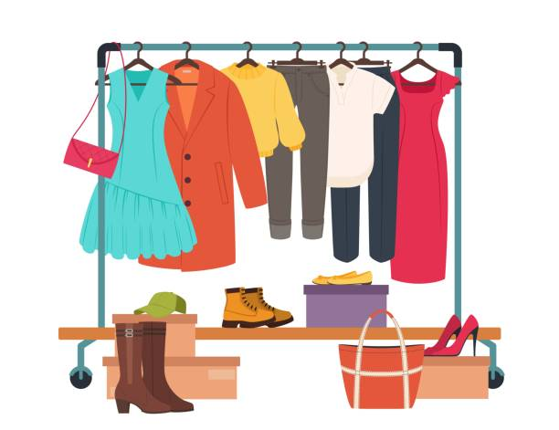

**INTRODUCTION:**

Texture Tales Clothing Company prides themselves on providing an optimized range of clothing and lifestyle wear for the modern adventurer!

I, the CEO of this trendy fashion company is asking you to assist the team’s merchandising teams analyze their sales performance and generate a basic financial report to share with the wider business.

**SCHEMA USED**

|  |  |
| --- | --- |
| product_details | |
| product_id | varchar |
| price | int |
| product_name | varchar |
| category_id | int |
| segment_id | int |
| style_id | int |
| category_name | varchar |
| segment_name | varchar |
| style_name | varchar |

|  |  |  |
| --- | --- | --- |
| sales | | |
| prod_id | varchar |
| qty | | int |
| price | | int |
| discount | | int |
| member | | varchar |
| txn_id | | varchar |
| start_txn_time | | varchar |

|  |  |
| --- | --- |
| Product_hierarchy | |
| id | int |
| product_id | int |
| price | int |
| start_date | date |
| end_date | date |

|  |  |
| --- | --- |
| product_prices | |
| id | int |
| product_id | varchar |
| price | int |

**CASE STUDY QUESTIONS**

1. What was the total quantity sold for all products?



SELECT

details.product_name, SUM(sales.qty) AS sale_counts

FROM

sales AS sales

INNER JOIN

product_details AS details ON sales.prod_id = details.product_id

GROUP BY details.product_name

ORDER BY sale_counts DESC;

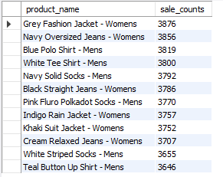

1. What is the total generated revenue for all products before discounts?



SELECT

SUM(price * qty) AS nodis_revenue

FROM

sales AS sales;

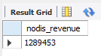

1. What was the total discount amount for all products?

 SELECT

SUM(price * qty * discount) / 100 AS total_discount

FROM sales;



1. How many unique transactions were there?

SELECT

COUNT(DISTINCT txn_id) AS unique_txn

FROM sales;

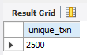

1. What are the average unique products purchased in each transaction?

 WITH cte_transaction_products AS (

SELECT

txn_id, COUNT(DISTINCT prod_id) AS product_count

FROM sales

GROUP BY txn_id)

SELECT

ROUND(AVG(product_count)) AS avg_unique_products

FROM cte_transaction_products;

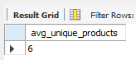

1. What is the average discount value per transaction?



WITH cte_transaction_discounts AS (

SELECT

txn_id,

SUM(price * qty * discount)/100 AS total_discount

FROM sales

GROUP BY txn_id)

SELECT

ROUND(AVG(total_discount)) AS avg_discount

FROM cte_transaction_discounts;

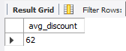

1. What is the average revenue for member transactions and non-member transactions?



WITH cte_member_revenue AS (

SELECT

member,

txn_id,

SUM(price * qty) AS revenue

FROM sales

GROUP BY

member,

txn_id)

SELECT

member,

ROUND(AVG(revenue), 2) AS avg_revenue

FROM cte_member_revenue

GROUP BY member;

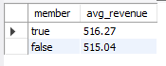

1. What are the top 3 products by total revenue before discount?



SELECT

details.product_name,

SUM(sales.qty * sales.price) AS nodis_revenue

FROM

sales AS sales

INNER JOIN

product_details AS details ON sales.prod_id = details.product_id

GROUP BY details.product_name

ORDER BY nodis_revenue DESC

LIMIT 3;

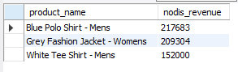

1. What are the total quantity, revenue and discount for each segment?



SELECT

details.segment_id,

details.segment_name,

SUM(sales.qty) AS total_quantity,

SUM(sales.qty * sales.price) AS total_revenue,

SUM(sales.qty * sales.price * sales.discount) / 100 AS total_discount

FROM

sales AS sales

INNER JOIN

product_details AS details ON sales.prod_id = details.product_id

GROUP BY details.segment_id , details.segment_name

ORDER BY total_revenue DESC;

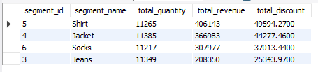

1. What is the top selling product for each segment?



SELECT

details.segment_id,

details.segment_name,

details.product_id,

details.product_name,

SUM(sales.qty) AS product_quantity

FROM

sales AS sales

INNER JOIN

product_details AS details ON sales.prod_id = details.product_id

GROUP BY details.segment_id , details.segment_name , details.product_id , details.product_name

ORDER BY product_quantity DESC

LIMIT 5;

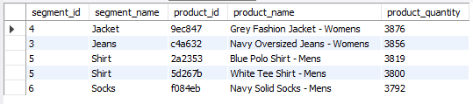

1. What are the total quantity, revenue and discount for each category?



SELECT

details.category_id,

details.category_name,

SUM(sales.qty) AS total_quantity,

SUM(sales.qty * sales.price) AS total_revenue,

SUM(sales.qty * sales.price * sales.discount) / 100 AS total_discount

FROM

sales AS sales

INNER JOIN

product_details AS details ON sales.prod_id = details.product_id

GROUP BY details.category_id , details.category_name

ORDER BY total_revenue DESC;

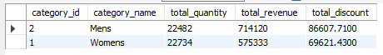

1. What is the top selling product for each category?



SELECT

details.category_id,

details.category_name,

details.product_id,

details.product_name,

SUM(sales.qty) AS product_quantity

FROM

sales AS sales

INNER JOIN

product_details AS details ON sales.prod_id = details.product_id

GROUP BY details.category_id , details.category_name , details.product_id , details.product_name

ORDER BY product_quantity DESC

LIMIT 5;

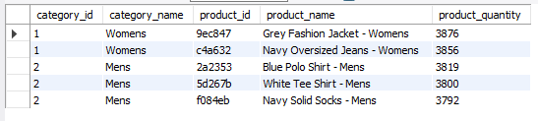

Hi,

Thank you for providing the instructions and guidance throughout the project. I learned a lot from this real-world scenario case study.

I'd love to connect with you on

LinkedIn: ( <https://www.linkedin.com/in/nikhil-kumar-roy/> ) and share my GitHub profile: ( <https://github.com/NikhilRoyDA> ), where you can find my work on this and different case study.

Thanks again for your support and guidance. I appreciate your help in my learning journey.

Best regards,

Nikhil Kumar Roy

